**Inventory Management System**

ProblemStatementMany organizations struggle to efficiently manage their inventory, track stock levels across multiple warehouses, and process orders in a timely manner. Manual inventory management often leads to errors such as stock discrepancies, delayed order fulfilment, overstocking, or stockouts. Additionally, communication gaps between suppliers, inventory managers, and sales teams can result in operational inefficiencies and missed business opportunities.  
  
The Inventory and Order Management System aim to address these challenges by providing a centralized Salesforce-based solution that automates stock tracking, manages orders, sends low-stock alerts, and streamlines approval workflows. This ensures accurate inventory visibility, faster order processing, and improved decision-making for businesses.

Phase – 1 Problem Understanding & Industry Analysis

**Requirement Gathering:**

* Track products across multiple warehouses with real-time visibility.
* Automate order fulfilment and restock requests.
* Provide low-stock alerts and approval workflows for large purchases.
* Ensure scalability, user-friendliness, and automation in the system.
* Support integrations such as barcode scanning, payment gateways, and Google Maps for order routing.

**Stakeholder Analysis**

* Warehouse Managers → need real-time stock visibility and restock alerts.
* Procurement Team → requires supplier tracking and purchase order automation.
* Sales Team → depends on live stock data to avoid overselling.
* Customers (B2B/B2C) → expect self-service portals to place orders and track deliveries.
* Management/Executives → demand dashboards for supplier performance, trends, and predictive analytics.

**Business Process Mapping**

* Current process: Procurement → Storage → Order Placement → Order Routing → Shipment → Restock Request.
* Pain points: manual approvals, frequent stockouts, overstocking, lack of visibility across warehouses.
* Salesforce improvements: automation via flows, approval processes, dashboards.

**Industry-specific Use Case Analysis**

* Retail → stock management across multiple warehouses.
* Manufacturing → raw material tracking and supplier reliability monitoring.
* Healthcare/Pharma → expiry-date tracking for compliance and waste reduction.
* E-commerce → nearest fulfilment centre routing and real-time delivery tracking.

Phase 2: Org Setup & Configuration

**Salesforce Editions:**

I have signed up for a new developer edition org for this project.

**Company Profile Setup:**

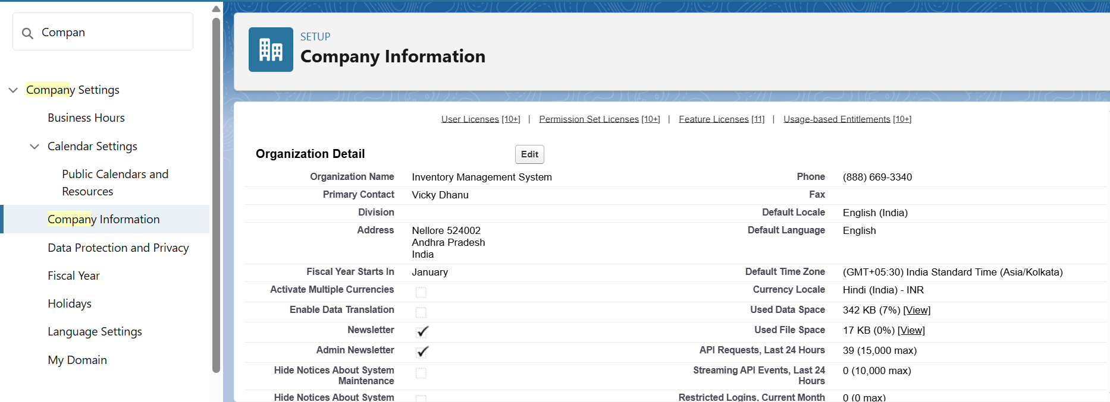

**Business Hours & Holidays:**

Our organization’s business hours  
 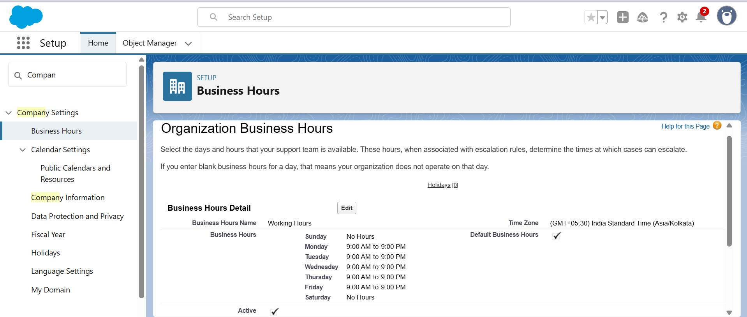

**User Setup & Licenses:  
  
Steps for creating users:**

* Click the gear icon you will go into setup.
* In Quick Find search users.
* click on users.
* In the user’s page click on create new user button and fill all the details like first name, last name, Gmail, username, role and profile you wish to give.
* I have created 3 users John Doe, Ajay Kumar, Nikhil Thomas.
* For John Doe, I gave Inventory Manager role.
* He can create, edit, delete products, inventory stock, orders.
* Runs Inventory and stock level reports.
* Can view warehouse staff and sales representative activities.
* For Ajay Kumar, I gave sales rep role.
* He creates sales orders for customers.
* Checks product availability before confirming orders.
* Reports to the Inventory Manager.
* For Nikhil Thomas, I gave warehouse user role.
* Cannot create new products.
* Can update the stock count.
* I myself acting as administrator.
* I have access to all the records.
* I will take care about the data loading etc.
* Below are the details of every user
* John Doe  
  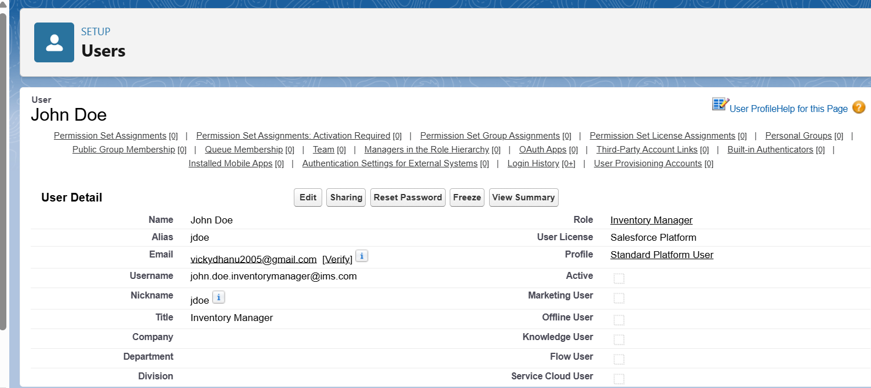
* Ajay Kumar  
  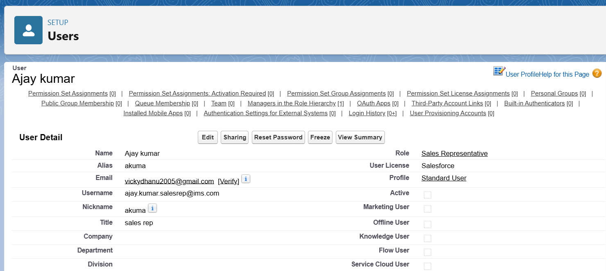
* Nikhil Thomas

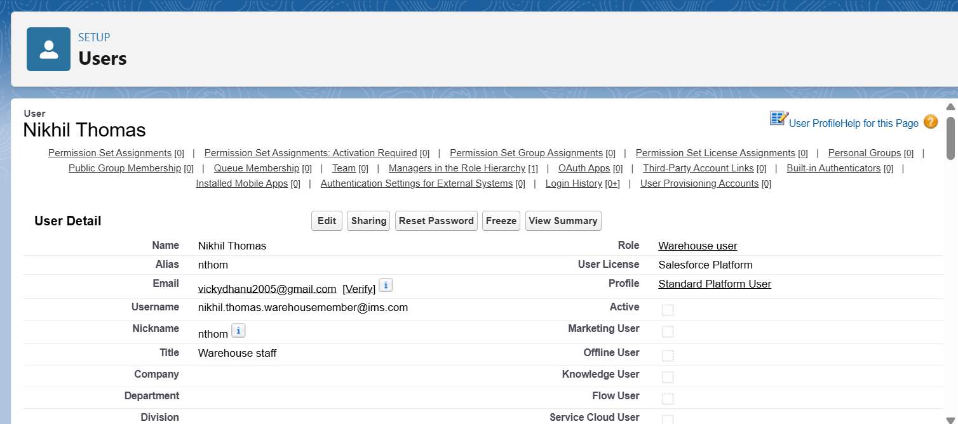

**Profiles:**

For the users I created I assigned the following profiles  
 Vicky Dhanu (Myself) – System Administrator  
 John Doe – Standard Platform User  
 Ajay Kumar – Standard User  
 Nikhil Thomas – Standard Platform User

**Roles:**

Following are the roles that I gave to my users of the project:

Vicky Dhanu – CEO / System Admin

John Doe – Inventory Manager  
 Ajay Kumar – Sales Rep  
 Nikhil Thomas – Warehouse staff member

Below is the screenshot representing the role hierarchy of the project  
   
 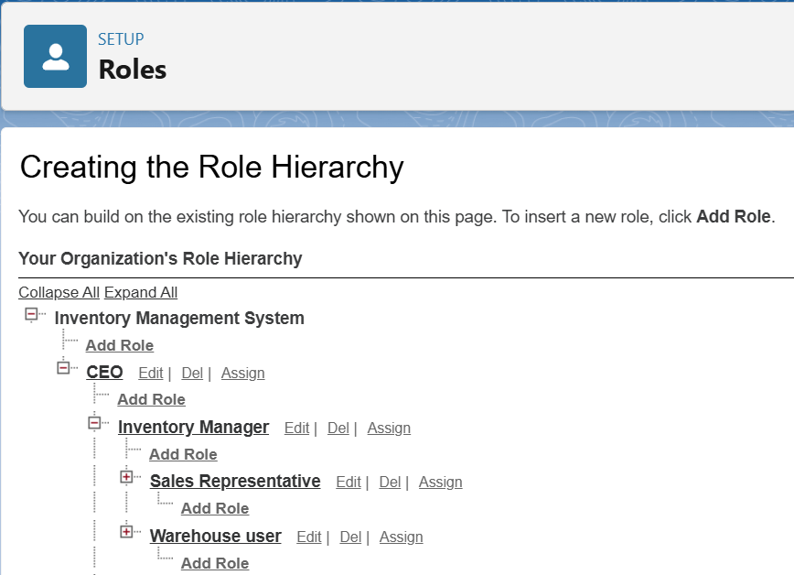

Sales Rep and warehouse user reports to the Inventory Manager.  
Inventory Manager reports to CEO.

**OWD:**

Below table gives details about the org wide defaults  
 Object OWD setting Explanation

|  |  |  |
| --- | --- | --- |
| Accounts | Private | Each Sales Rep should only see their own customers; managers see all via hierarchy. |
| Contacts | Private | Tied to Accounts; ensures customer information is secure per Sales Rep. |
| Orders (Custom) | Private | Orders created by Sales Reps are only visible to them; managers can see all. |
| Products | Public Read Only | All users should see available products, but only Inventory Manager/CEO can edit. |
| Inventory (Custom) | Public Read Only / Private | Sales Reps can view stock; Warehouse Staff & Inventory Manager can update. |
| Reports & Dashboards | Controlled by Parent | Visibility is determined by the access level of the underlying object data. |